Wiradjuri Country

60-62 Maxwell Ave, ORANGE, NSW 2800

Tel: (02) 6362 7191 Fax: (02) 6362 2133

ABN: 21507947901

Email: [glenroihts-p.school@det.nsw.edu.au](mailto:glenroihts-p.school@det.nsw.edu.au)

Also find us on: 

**NEWSLETTER**

***Term 3 Week 3***

*2nd August 2022*

***Message from our Principal***

Dear Glenroi Families,

This week we celebrate NSW public education with the theme **"Creating futures- education changes lives"**. Watch out for a special video this week on our Facebook page which will celebrate our students' futures. At Glenroi Heights PS we are all dedicated to our school and the best interest of our students is at the heart of every decision we make. This year's theme reminds us of the journey of learning and how each students path looks different. We celebrate our students' unique personalities, strengths and passions. Students can **dress up**on **Friday** 5th August as "*what they want to be when they are older"*.

Ducan Auld (Director Educational Leadership, DEL) visited our school last week and was very impressed with the**student learning and new school uniform**. Mr Auld has been away from his position for 18 months supporting the department with COVID programs. Our students were very respectful talking to him about their wonderful learning and their fabulous classrooms. Thank you to all staff and students for making our DEL feel welcomed. We are very proud of our school and this shone!

**PLP meetings** can be booked for **week 4 Monday 8th August to Thursday 11th August 2022**

Please log into school interviews and use the code **smzby. Scan the QR code found in this newsletter for quick access!**

All teachers are available on Tuesday afternoon and each stage has been assigned an afternoon. We have in-person meetings or phone meetings available.  All meetings that are in-person require parents/carers to wear a mask, practice social distancing and use hand sanitizer. Please sign in at the office before the meeting. If you require support to book a meeting, please call 6362 7191.

We are excited to be sending a variety of staff to the **Berry Street Educational Model** (BSEM) professional learning. The training provides strategies for teaching and learning for all students. Staff will learn best practices for teaching self-regulation, relationships, wellbeing, growth and academic achievement. Positive education, trauma-informed teaching and wellbeing practices will continue to be embedded within the Glenroi Heights structures.

|  |  |
| --- | --- |
| **UPCOMING EVENTS** | |
|  |  |
|  |  |
|  |  |
|  |  |
|  |  |
| **May 26th** | National Sorry Day |
| **May 31st** | Musica Viva |
| **June 13th** | Queen’s Birthday Public Holiday |
| **July 1st** | Students last day of Term 2 |
| **July 18th** | Staff development day |
| **July 19th** | Students first day of Term 3 |
| **September 23rd** | Students last day of Term 3 |
| **October 10th** | Students first day of Term 4 |
| **December 19th** | Students last day of Term 4 |
| **December 20th** | Staff development day |

As we continue into the winter season, we are asking families to **please keep students at home if they have cold and flu symptoms.** Students can attend school if they are a household contact and do not have symptoms. They must wear a mask, take a RA test each day for 5 days and have a negative result.

Students in a support class are still required to isolate if they are a household contact. The Deputy Secretary has assured all principals that this will be reviewed after week 4 as they recognize that not all students with a disability are medically vulnerable. NSW Health advice has not changed therefore the guidelines are the same. We will send any student home if they have cold and flu symptoms during this time to ensure the safety of all staff and students. Thank you for understanding.

Have a wonderful week

Tegan Davis

Principal

Please log into school interviews and use the code

**smzby**

Or please use the QR code provided

**PLP meeting QR code**

If your child is starting Kindergarten in 2023, contact the school for information on how to enrol in this fabulous program!

**Canteen**

**Monday / Wednesday / Friday**

**Please place your order before 9am**



**HOT FOOD:**

**Cheese Toastie $2.50**

**Cheese & Tomato Toastie $2.80**

**Ham & Cheese Toastie $3.80**

**Grilled Chicken Tenders (x3) $4.00**

**Sweet Chilli Chicken Tenders (x3) $4.00**

**Spaghetti Bolognese $4.00**

**Chicken, Mayo & Cheese Toastie $4.50**

**Pasta Bake $4.50**

**Sausage Roll $4.50**

**Cheese Pizza $4.50**

**Ham, Tomato & Cheese Toastie $4.80**

**Chicken, Mayo, Tomato & Cheese Toastie $5.00**

**Grilled Chicken Burger with mayo $5.00**

**Ham & Cheese Pizza $5.00**

**Meat Pie $5.00**

**ORDER ONLINE**

Download the Spriggy app www.spriggyschools.com.au

**SNACKS:**

**Carrot Sticks $0.50**

**Apple $1.00**

**Yogurt (Passionfruit, Vanilla OR Strawberry) $1.50**

**Orange Wedges $1.50**

**Corn $1.50**

**DRINKS:**

**Water $1.50**

**Orange Juice $1.80**

**Apple & Blackcurrent Juice $1.80**

**Apple Juice $1.80**

**Strawberry Milk $2.00**

**Chocolate Milk $2.00**

**SANDWICHES:**

**Jam $2.00**

**Vegemite $2.00**

**Cheese $2.00**

**Cheese & Tomato $2.50**

**Tuna $3.00**

**Ham $3.00**

**Ham & Cheese $3.50**

**Tuna Salad $4.00**

**Ham, Cheese & Tomato $4.50**

**Chicken Salad $4.50**

**Ham Salad $4.50**

**Chicken, Lettuce & Mayo $4.50**

**Ham, Cheese & Salad $5.00**

**Chicken, Cheese & Salad $5.00**

**UNIFORM SHOP**

**Please see the office**

**Hats $10**

**Shirts $10**

**Jumpers $20**

**Jackets $40**

|  |  |
| --- | --- |
| **UPCOMING EVENTS** | |
| **Monday**  **2nd August**  **Week 3** | *Education Week* |
| **Friday**  **5th August**  **Week 3** | Dress Up Day  Come dressed as what you want to be when you grow up! |
| **Friday**  **5th August**  **Week 3** | All payments due for Term 3 Swimming |
| **Monday**  **8th August**  **Week 4** | PLP meetings begin |

**Swimming lessons for years 3 – 6 commence Monday 25th July. Please have permission forms back before swimming lessons start. $25 payment is due by 5th August.**

**Reminders:**

* Glenroi Heights is unfortunately unable to process payments via the phone. Payments can be made in person to the office (Cash or EFT) or via the school website using the Parent Online Payment (POP). Glenroi-p.schools.nsw.edu.au
* As the temperature falls, the rate of lost jumpers seems to climb. Please remember to put your child's name on ALL their belongings including their school jumpers, jackets, and hats. We also ask that your child only wears their school jumper and jacket and that their save their casual jumpers for after school and on the weekends.
* If you have placed a lunch order and your child is away on that day, please contact the office to arrange for that order to be postponed. (02) 6362 7191

LOOP is the Scholastic Book Clubs Linked Online Ordering & Payment for Parents.

Log on to [www.scholastic.com.au/LOOP](http://www.scholastic.com.au/LOOP) or download the LOOP app

for all Book Club orders.

**At *Glenroi Heights Public School* we love healthy lunches.**

Please ensure that students lunch boxes are packed with two serves of fruit/ vegetables, a sandwich, water, and healthy choice snack foods.

**Let us all be Strong, Smart, and Proud and represent our school with pride!**

Please remember our uniform consists of:

* Black shoes
* Black pants
* GHPS bucket hat
* GHPS jumper, shirt, and jacket to be worn

**Strong Connections**

We built Strong Connections with our guest Max Wilson, captain of Canobolas High School, for Putt Putt Golf for Yindyamarra. Our students gained knowledge about high school and showed amazing sportsmanship encouraging one another whilst hitting golf balls.

Kylie Greatbatch || Coordinator

**CONGRATULATIONS Mrs Wilson and Aunty Alice!**

I graduated on Friday 24th June from Wiradjuri Language Certificate III

Our class of 2022 had 17 in total who graduated.

Aunty Alice Williams has been on this journey with me right back when we started Certificate I in 2018. We have been each other's strength and support in different ways and come such a long way in those 4 years. A friendship that I will treasure for my lifetime. The beautiful Aunty Iris Reid has been our Wiradjuri Language teacher right from the get-go too and I cannot thank her enough for all the support she has given me, I appreciate her so much

And....now some of us are ready to jump back into it in 2023 to take on Certificate IV

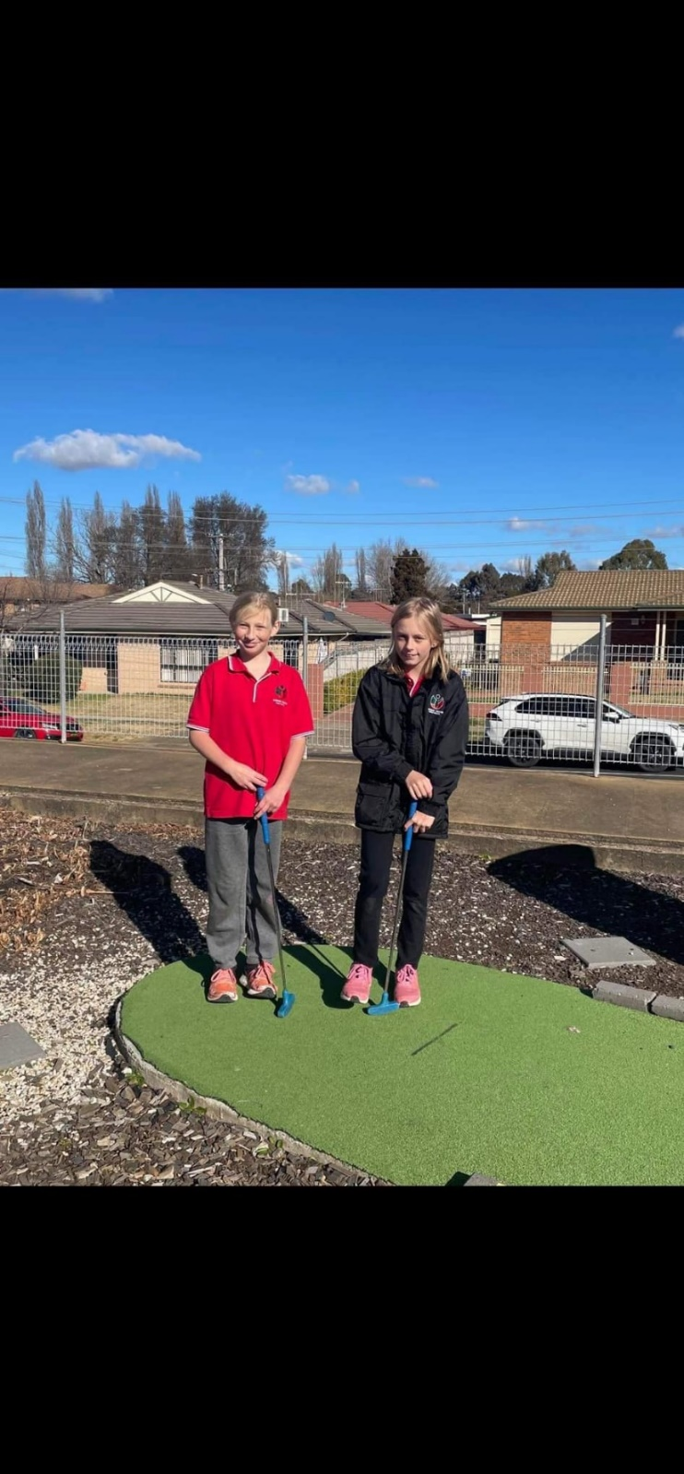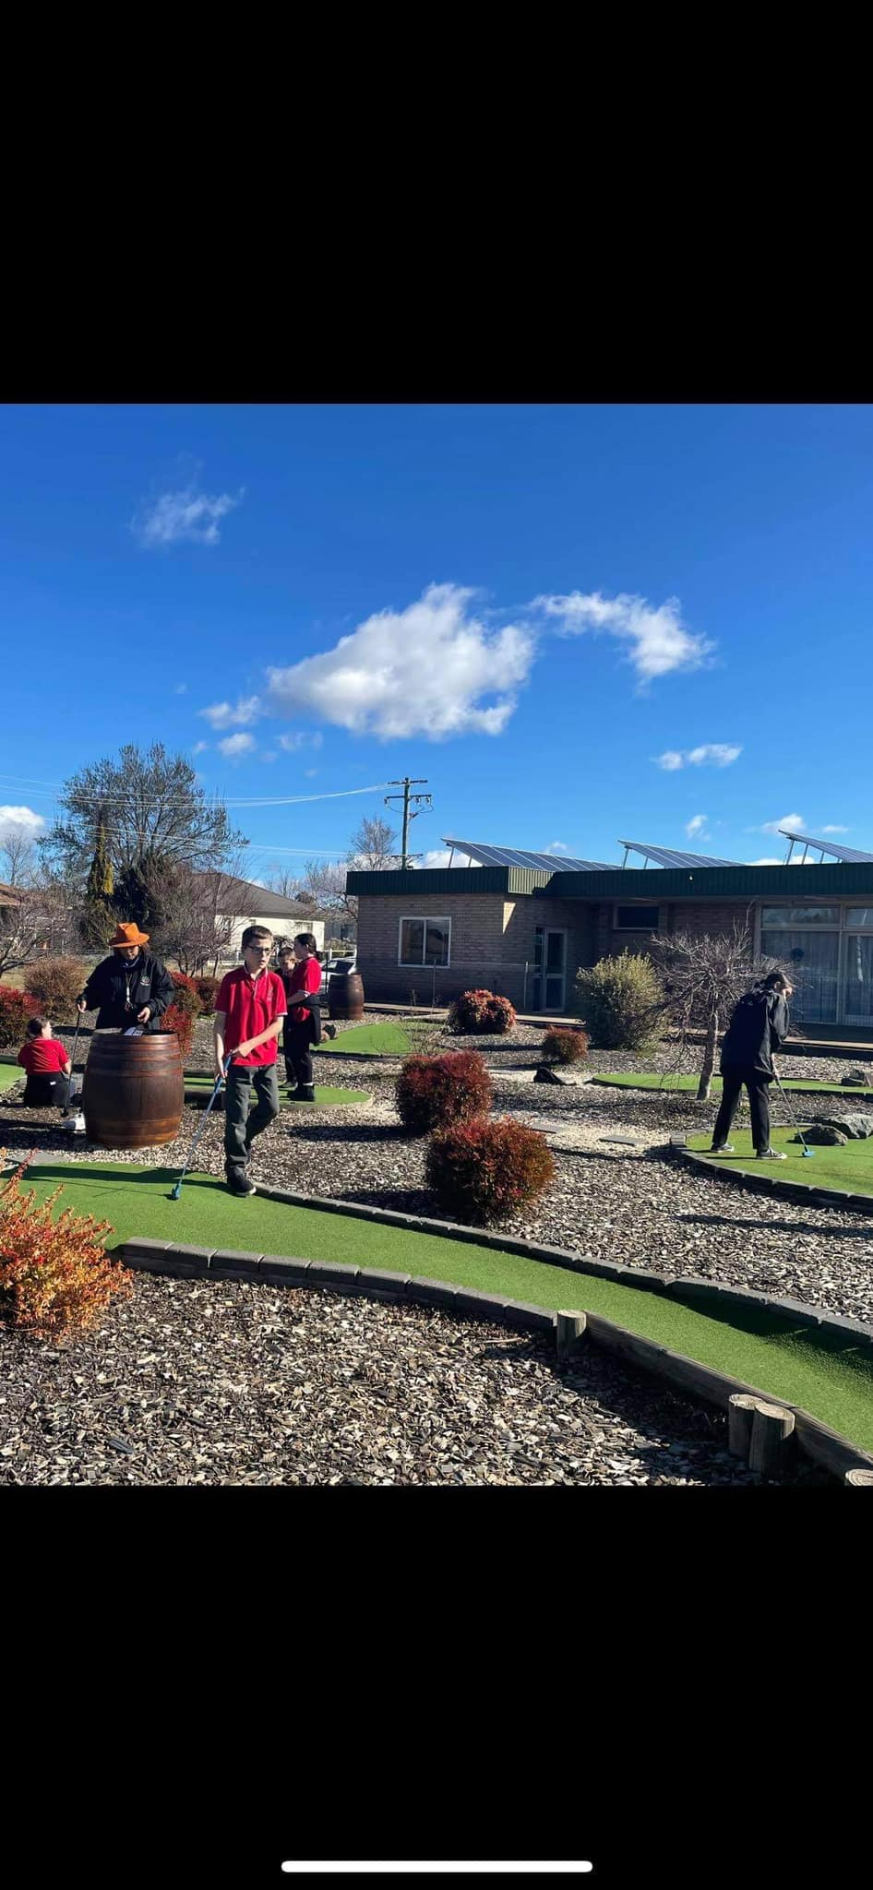**Putting the PROUD into Strong Smart Proud**

Stage One students love to share their successes and efforts with their peers. By visiting other classrooms, they inspire each other, seek, and take on feedback, and simply show off their amazing work!

Jemma Selwood || Teacher

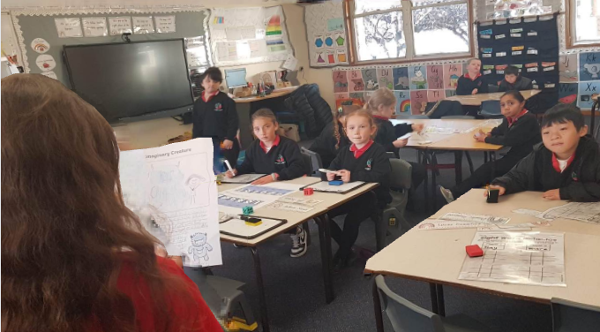

8 Tips ✅

It can be such a challenge when the weather is so cold outside to limit our time on devices. Check out the 8 tips to support both your child’s and your device usage.

Rhys Hill || Classroom Teacher



**Community notices**

**STUDENT ABSENCES:**

If your child is late to school, please present to our office with an explanation and to receive a *LATE PASS* for your child to give to their classroom teacher.

If you’re collecting your child early, please present to our office to sign out and collect your child.

If your child is absent from school, please call, email, or provide a note as soon as possible. Please feel free to use the absence slips below. Thankyou

**Absence Reminder**

**Date:** ______________________ **Name:** ________________________

**Of class:** ___________________

**Will be/was absent from school on the following dates:**

____________________________

____________________________

____________________________

**Reason:**

______________________________________________________________________________________________________________________________________________________________

*Parent/ Carer signature: Please return to classroom teacher or front office*

**Absence Reminder**

**Date:** ______________________ **Name:** ________________________

**Of class:** ___________________

**Will be/was absent from school on the following dates:**

____________________________

____________________________

____________________________

**Reason:**

______________________________________________________________________________________________________________________________________________________________

*Parent/ Carer signature: Please return to classroom teacher or front office*